### World Rebroadcast Total world self salvation methods of GOD. info@FortuneONE.org 770-377-2106
Gods individual Simple solution methods to unify all mortals one final time use of EVOTE.ONE UNIocracy.org FORTUNEone.ORG $40 Billion USD NGO revolution Equalizer Philantrophists.
TheMegaPhysics.org *.Foundation -describes all aspects of HOW and WHY GOD procreated each of you.
DueProcessLaw.org -Jan 8, 2024 -Basic total replacement of all Laws worldwide protect WE the People.

4Peace.Foundation Dec 13, 2023 -Simple basic GODs methods of WE the people own all assets.
FourPeace.org Dec 13, 2023 -self evident WE GODs People are only caregivers caretakers of all.
5steps.life *.LIVE Nov 4, 2023 -Basic GODs generator for all mortals to solve prevent any problem

AirCraft.TODAY Jan 8, 2023 -Showcase of worlds last general aviation Best solutions worldwide.
BankONE.Foundation Dec 19, 2023 -One central bank composed of ONLY Local credit Unions worldwide.
BeSmartBeRich.com Sept 23, 2023 -Basic everyone self sustainable forever free of ALL wars + Politics.
BidOnKeith.com Aug 6, 2023 -Basic trillion USD consulting enterprise umbrella corporation Model.
builtbykeith.com Nov 19, 2023 -Original GODs system of BUILDING new world no crime societies.
builtbykeith.org Sep 26, 2023 -Ditto. Procreator of GODs new world no crime no politics system.
CcwGUARD.org Oct 16, 2023 -Community Crime Watch Guard prevents 95% any crime issue forever.
ChildProtectCoalition.com Apr 8, 2023 -Destroys the child predators mostly middle age, elderly males.
ChristDomain.org *.com Sep 4, 2023 -Unifies all religious leaders cooperating collective Spiritual Leaders.
ClearCollarCrime.com Sep 5, 2023 -Identify destroys the worst criminals cyber terrorists who roam freely.
CreatorKEITH.com Aug 16, 2023 -One elder group single universal overseer Guardian Angel protectors.
info@creatorkeith.com Business Email Apr 11, 2023
DeadSilent.space Sep 5, 2022 -Describes why 99.5% of mortals are dead silent unable to move forward.
DOSJ.ORG Jul 28, 2023 -New single one world Dept of Social Justice of all DOD DOD combined.
DueProcessLaw.ORG Jan 8, 2023 -Single New World standard of GODsConstitution.com applied to all.

DuncanCLAIM.org Sep 23, 2023 -$500 MILLION USD class action landmark miscarriage of Justice filed
Cobb County 22-1-3042-68 May 3, 2022 most powerful profitable public scandal of all time RR ROSE.
e911.club April 17, 2023 -Emergency 911 universal exchange of reporting any crime enterprises.
E911.space April 17, 2023 -Ditto.
EarthFirstConcert.com March 1, 2023 -Worldwide Town Hall Forums PeaceSummit2020.com celebrities.
EcoWorld.Foundation Dec 11, 2023 -perfected complete 100% comprehensive ECOLOGY GODs way.
WorldEco.Foundation -ditto reverse all climate change same as EcoWorld.* SaviorKeith.com
ECRAFT.us May 21, 2023 -New world General Aviation GOD engineered systems fossil free.
Ee911.org April 17, 2023 -Peer to Peer electronic Emergency Communications peer to peer answer.
EE911.us April 17, 2023 -Ditto at individual level of WHO is WHO of FOIA.ONE
ElectronicNAPKIN.com Sept 27, 2023 -+2 Billion USD original universal stabilizing all way Comm System.

EVOTE.ONE Aug 9, 2023 - Most powerful single GODs answer of WE DECIDE everything.
FatherKeith.com Dec 29, 2023 -GOD sent ProphetKeith.com world self saving tech Ministries.
FinalStockMarket.com Apr 2, 2023 -Destroys all public traded stock stick market lucifer systems forever.
FindKEITHaWIFE.org. -Nov 7, 2023 - Basic perfected Relationship ReManagement GODs systems.
FOIA.ONE Aug 29, 2023 -Single new world GODs database OPEN PUBLIC shared by all.
FollowKEITH.ORG - Aug 18, 2023 -Basic WHO was KEITH based on GODs John 10:30 PRUMC.org
followkeith.us Aug 8, 2023 -Requirement to followKeith to learn how to be Sovereign forever.
FOR-Peace.org Dec 14, 2023 -Self Evident Self Saving for all 8B mortals forever.

FortuneONE.org Sept 10, 2023 -New World crime free OVERSEER all governments + Corporations.
FourPEACE.org Dec 13, 2023 -Self Evident fast path for 8 billion humans to be only PEACE MAKERS.

FORTUNE.PW - Sept 10, 2023. Self Evident Password of unlocking all criminal secrets forever.
FreeBUS.US Feb 26, 2023 -All electric free transportation system converts existing methods.
FreeBUS.space Feb 26, 2023 -Ditto.
FreeNuclear.org Aug 14, 2023 -Powers our new world recommission all nuclear materials.
freetrains.us Jul 8, 2023 -Free high speed freight and passenger service worldwide.
FreeTransport.us Dec 20, 2023 -Combination of repurposing all corporate aircraft and yachts.
GivingALL.biz March 16, 2023 -Business of giving all of GODs resources back to OUR needs.
GivingALL.space March 16, 2023 -Basics of giving everything to those in greatest needs.
GivingALL.us March 16, 2023 -Always was about YOUR total Outreach Ministries to all others.
GivingPledge.space Jul 31, 2023 -WE control all mega billionaires and MILKanaries forever.
GODsAdvocate.space April 9, 2023 -Simple use of GODs original LOVE ALL commandments.
GODsAdvocate.us April 9, 2023 -All about US, never ME or THEM again. Always YOU benefit.
GODsAdvocate.xyz April 9, 2023 -Advocate ditto.

GODsConstitution.com April 30, 2023 -Single new world no crime politics terrorist commandments.
GodsCRUSADE.org Nov 29, 2023 -Exact reason why GOD sent KEITH alone to unify all mortals.

GODsPeople.Online Aug 30, 2023 -Each person always part of GODs +8 Billion People Family.
GodsPEOPLE.space April 30, 2023. -Ditto from another GODs angle.

GodsUNIVERSE.US. Feb 1, 2024 -Self Evident showcase of WHY each of YOU were procreated.
GodsUNIVERSE.Space Feb 1, 2024 -Construction of New World Order managed by each of YOU.

GodsUNIVERSITY.Today, *.WORLD, *.INFO Jan 3, 2023 -Perfected GODs plan of Re-Education.

HelpInmates.org Oct 16, 2023. -Most massive successful campaign to prevent crime in first place.
gtreyes.com Sep 24, 2022 -Gloria Reyes in Manila requests being your top scientist engineer.
ifjc2.com Jun 16, 2023 -I Follow JESUS CHRIST TOO, WHO do you follow or lead?
InterPOLICE.live May 31, 2023 -New World InterPolice Replacement DOSJ.org OUR law system.
IseeJUSTICE.com Feb 6, 2024 -Who sees Justice and acts with fearless authority to protect others.
IseeJustice.org Jul 31, 2023 -Ditto from Non Government, non religious viewpoints of reality.
IseeSTAND.org Aug 8, 2023 -Original world first to market selfy-stick universal stabilizing patent system
JoyDrive.us May 3, 2023 -Converts ALL vehicles and future to all electric VOICE Command.
k911app.com Sept 19, 2023 -Peer to Peer Mobile universal reporting System of GOD + YOU.
k911.space Aug 26, 2022 -ditto. Original GODs e911.mobi year 2010 same universal perfected system.
kbitcoins.org Aug 23, 2023 -One new world universal stabilizing Currency. NO bitcoins, forex, scams.
keith2022.com Jan 8, 2023 -Original GOD sent Keith Duncan Portfolio from 64 years ago.
KeithAirService.com Oct 13, 2023 -Conversion of ALL corporate aircraft/yachts to 100% humanitarian use.
KeithDuncan.org Nov 20, 2023 -Original WHO was KEITH sent by GOD alone to save all humans forever.
KeithLAWFIRM.org Jan 5, 2023 -Buys out most world law firms to reverse all LIAR LAWYER profits for US.
KeithsRulesOfOrder.com Apr 15, 2023 -Basis of host mediating ANY dispute, business issue worldwide.
KeithYachts.com Feb 14, 2024 - Conversion build out of Ocean seafarer Explorer for deep clean our Waters using direct funds of NGOs from GivingPledge.SPACE megaBillionaires we control forever.
LaserTunnel.com Apr 27, 2023 -100% green new eco mining system to rebuild GODs uniocracy.org
LearnFirstNames.com May 3, 2023 -Basic WHO is WHO and all other aspects of 1 degree separation.
LiberateFILIPinos.org Feb 21, 2024 -Liberates each nation known as Federalism perfected by Keith.
LUCIFERAgenda.com Jan 27, 2023 - Basic description of Satanic Demonic LUCIFER mindsets.
MANHuntALL.com Aug 21, 2023 -Easy to use manhunt down any violator of OUR human rights.
maryrights.space Expired Jul 22, 2022 -Ministry to return all overseas workers once and forever.
MotherEARTHconcert.com Jan 12, 2023 -Music ministry to unify mankind one final time.
MotherEarthConcert.info expired Jan 12 -Ditto. Ties 100% directly into PEACEsumMIT2020.com series.
MountainPower.org Aug 8, 2023 -Consultants extreme for all water powered world of WE the people.

NewsONE.Foundation Dec 24, 2024 -Replaces ALL news media with only PBS, NPR worldwide.

NewZion2.com Jun 16, 2023 -New Zion2 to rebuild Gods temples of education worldwide.
NoUnion.TOP, NoUnion.Space, NoUnion.Foundation - Gods people are ONE UNION forever.
OneBank.Foundation Dec 19, 2023 -ONE NoCentral Bank for entire world. No fees, No criminals allowed by order of WE GODs People. Simple NO fee total control over our Assets forever.

OneGODworks.org Dec 14, 2024 -Describes WHY we have only ONE FatherGOD + MotherEarth.
OnePress.space, OnePress.Foundation Dec 13, 2022 -We control all news PBS worldwide.
PressONE.foundation -ditto Our PRESS motivates WE THE PEOPLE to take direct command action.
PeaceActivist.Foundation Nov 20, 2023 -Final Name of WHO WE always were. Led by Keith Duncan +
PeaceAvist.foundation Nov 19, 2023 -Name of WHO are WE the PEOPLE Peace Activists forever.
PeaceAVIST.org Nov 19, 2023 -Ditto self evident replicated enforced integrity everyone by contracts.
PeaceSummit2020.com Sep 27, 2023 -Easy host mediated your community resolve any issue.
Peacesummit2022.com Expired. Dec 23, 2022 -Current year 2022 ditto.
PEACEsummit2023.com. OCT 23, 2023 -Prophesied survival of each of Gods +8 billion children.
PhoneCradle.org Aug 8, 2023 -Original first to market universal stabilizer for all humankind.
ProfitKeith.com Nov 5, 2023 -Everyone deserves to get paid FIRST, never again last slave traded.
ProfitShareHolders.com Aug 21, 2023 -most fundamental HOW YOU share 1st profits forever.
ProphetKeith.com May 29, 2023 -basic description of WHY GOD sent keith alone to unify all of you.
ReInvestALL.com Feb 17, 2023 -Basic destruction of all corporate executives at bank and stock levels.
ReManAdate.ORG Jun 27, 2023 -How to find best permanent lifetime partner equality spouse forever.
SaintKeith.com Sep 12, 2023 -WHo was Keith Brent duncan IID FOIA.one 1-19580815-1 Left behind.
saviorkeith.com Nov 28, 2023 -WHO was KEITH, WHO are YOU? is most asked question of all time..
SDRUGS.org Jan 2, 2023 -GODs fast path methods of reversing ANY addiction known to man forever.
SkyLift.us May 8, 2023 -Simple metaphysics to eliminate almost all fossil fuel transfer of weight.
SmartBreaker.us Jul 15, 2023 -Saves 10 to 50% of all world electricity at patent breaker transfer level.
SmartSmoke.us Jul 15, 2023 -Worlds last to market prevention of almost all fire smoke incidents.
SolutionBankFraud.com Apr 12, 2023 -Basic year 1976 invention of how to prevent any database transfer.
solutionBank.space Dec 13, 2022 -Ditto from year 2010 destroyed by terrorist ROSE and Brian Walker.
solutionBattery.org Nov 11, 2023 -Basic metaphysics simple upgrade scalable use of storage of energy.
SolutionBusiness.org Dec 8, 2023 -100% basic how to create best business one time every time.
solutionDrugs.com Jul 31, 2023 -Basic most powerful anti all drugs educational series run by you.
solutionENERGY.biz Nov 23, 2022 -Overview of how to eliminate all energy wars of the Lucifer Executives.
SolutionENERGY.space Nov 19, 2023 -Ditto New World 99% all free Energy WE = OUR systems
SolutionENERGY.us Nov 19, 2023 -Complete energy independence of everyone at COMMUNITY level.

solutionGOD.org Jun 16, 2023 -Basic reality of WHY GOD procreated each of you human mortals.
SolutionGovernment.ORG Sept 14, 2023. Describes NO politics, No Taxes NO Crimes year 2010.
solutiongovernment.COM Dec 20, 2023 -Worlds last non government systems year 1976-2023.
SolutionGunControl.com Aug 21, 2023 - Revolutionary stabilizing BT trigger lock all gun control forever.
SolutionHousing.org Aug 6, 2023 -Everyone now builds their own anti all crime communities forever.
solutionJUDGE.com Aug 19, 2023 -Basic new world total replacement tort judicial reform GODs system.
solutionLAWenforceMENT.com Apr 21, 2023 -Basic everyone shares WHO is WHO at all levels forever.
SolutionMANifesto.com Aug 6, 2023 -Total replacement of all of GOD due process of laws forever.

SolutionMEDIA.org Dec 7, 2023 -Simple WE GODs people control manage ALL news Media worldwide.

solutionMED.org Nov 15, 2023 -Simple GODs technology to reverse any disease system forever.
Following: No more Co-Pirates control OUR news distribution all services forever. We control all.
SolutionMEDIA.org Dec 7, 2023 -Chops up ALL TV RADIO NewsPaper OUR media to only GODs PBS.
solutionMILITARY.com Aug 8, 2023 -Removes all Commander in Chief Congress DOD authorities.

SOLUTIONPEACE.org Aug 6, 2023 -Showcases all of GODs methods to create Utopia of Heaven.
solutionSAFEwater.org Aug 6, 2023 -Simple Hydro Water Turbines now produce 90% all world energy.
SolutionURL.com Dec 19, 2023 -Resurrected YOU ARE LOVED single World unification Gods method.

TeamMONEYmachine.com Jun 6, 2023 -Basic how to procreate any business service successful 1st time.
TeenMM.com Mar 17, 2023 -Ditto. Original TeenMoneyMachine.com keith procreated year 2000.
teentagalog.space Jul 22, 2022 -Philippines version Tataglog of TeenMM.com for all to now use.
TheMetaPhysics.Foundation Nov 15, 2023 -Describes GODs procreated purpose for each of you.
TheMetaPhysics.org Nov 15, 2023 -Ditto. Greatest Philosopher of all time Keith Brent Duncan.

TurnOffLights.Com Sep 1, 2023 -Basic metaphysics patents that reverse all climate change wars forever.

UNIocracy.org Aug 6, 2023 -Gods perfected completed new world peace making engineered systems.
VoiceCommand.biz Nov 8, 2023 -How to control manage own all of GODs resources universally.
VoiceCommand.pw Nov 8, 2023 -Ditto. Self Evident.(c)(tm)(r) WorldPTO.com by Keith Duncan
VoiceCommand.us Nov 9, 2023 -All eDevices now controlled by your voice commands at all levels.
WaWaLake.org Sep 24, 2023 -First major Philippines modeled free electricity hydro water systems.
WhereIsRobertRose.com Apr 21, 2023 -Basic FIND any cyber criminal terrorists using Keiths methods.

WorldPTO.com March 11, 2023 -The ultimate only solution of Filing any (c)(tm)patent one World Time.
World Patent Trade Office Community Share Everything Database.
WorldSchoolFund.org Sep 4, 2023 -100% free world foreign exchange all new world education system.

WTFOne.org Nov 17, 2023 -World Trade Foundation overseers of all Corporate trading markets.

YodaKEITH.com *.ORG Oct 28, 2023 -Describes WHO was KEITH fighting all Lucifer Demons.
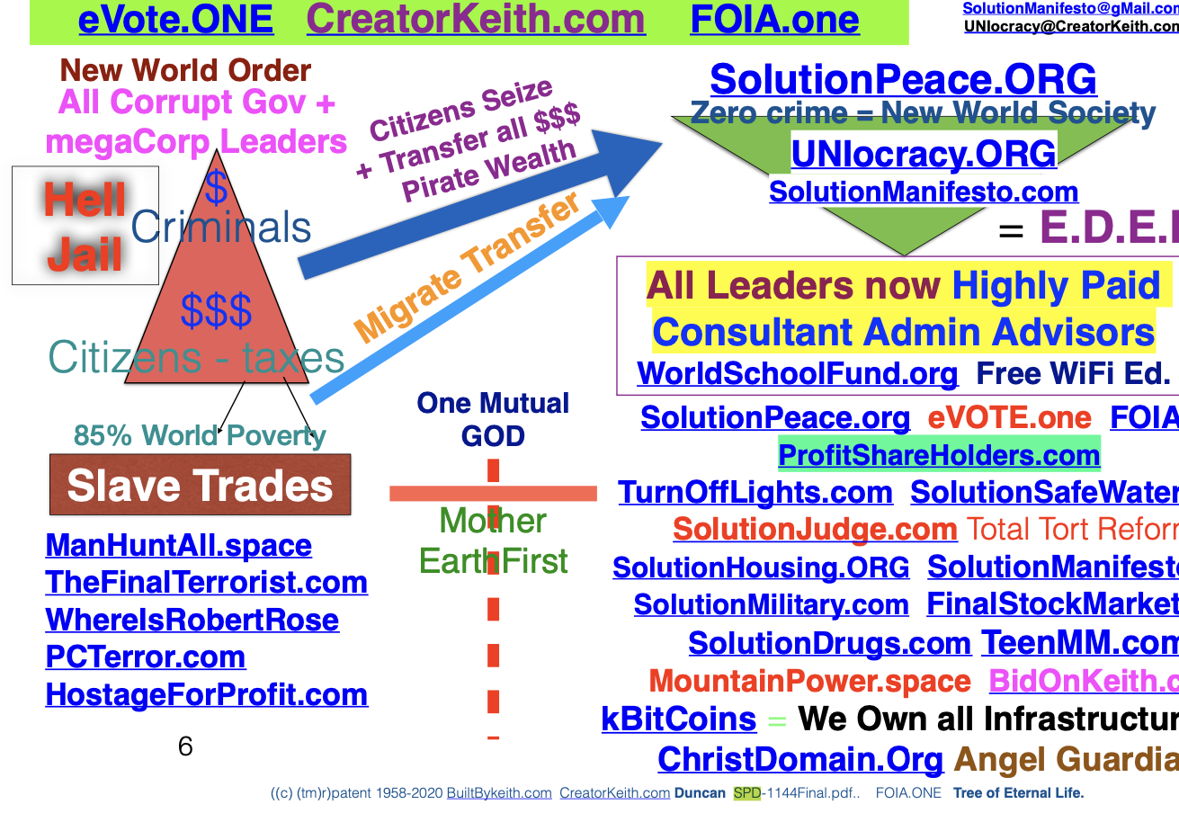
#### End of Gods solutions now 154 Strong ONLY answer methods.
UNIOCRACY.org Intl Headquarters +1 770-377-2106. ENJOIN everyone to Be free Will Sovereign citizens.

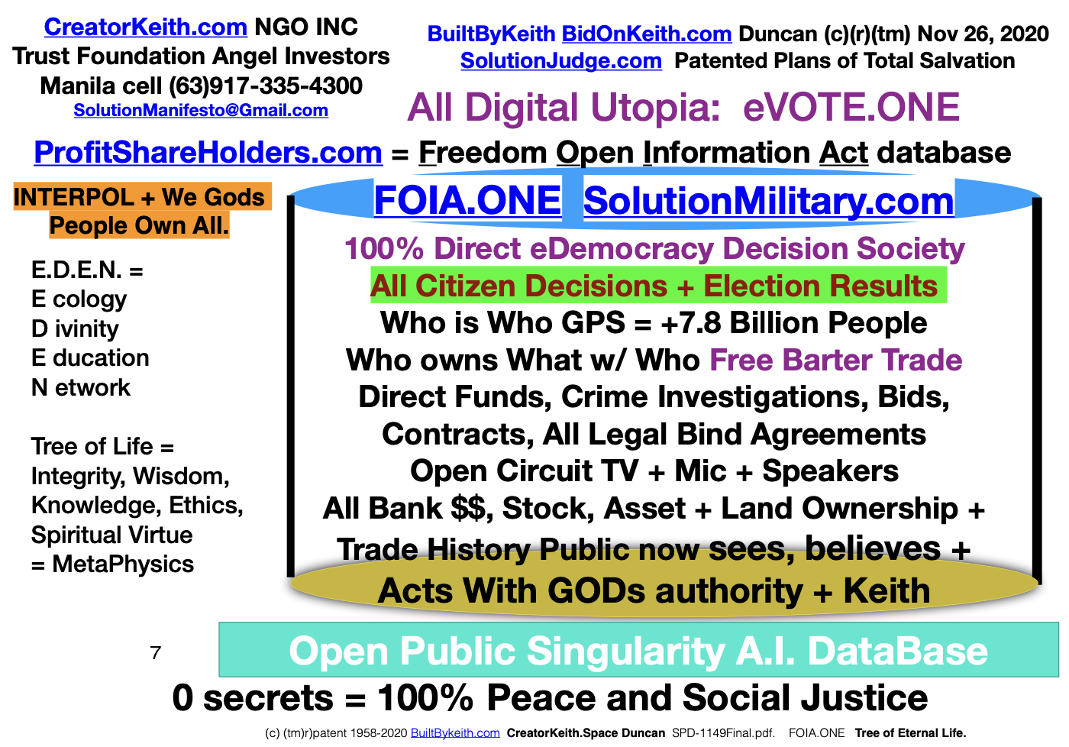
Page 5 of 5

